Running2Win

- Go to http://www.running2win.com/
- Select Register me!
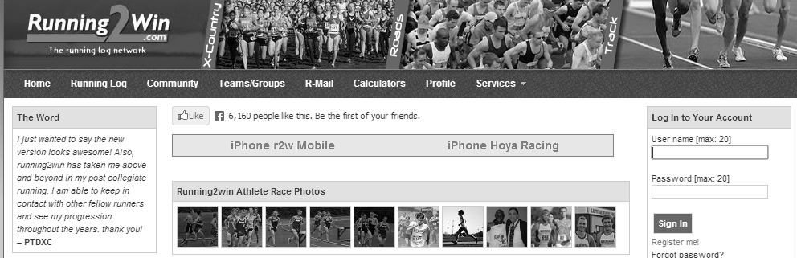
- Enter your information
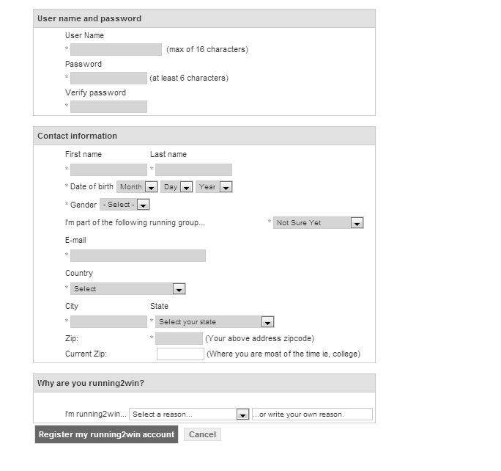
- Under Teams/Groups select join a team
- Enter Team ID T-46296110110-26
- Select Submit Request
- The Team Admin will approve your request and add you to the Track & Field Group.
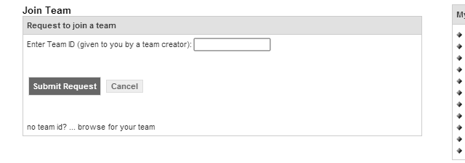
- Under Running Log enter your shoe information. Running shoes have a life span of 300 to 500 miles on them. Entering your shoe information is a great way to help keep track of the miles on your shoes.
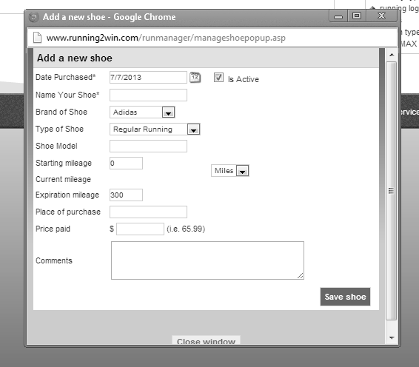
- Under Running Log, select log a workout. This offers a lot of details for your running and non-running workouts
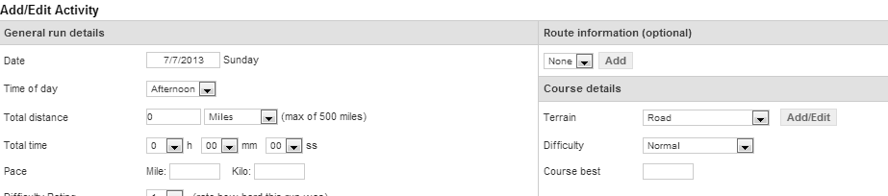
- A fun tool to play with is Routes & r-maps under Running Log. One can map out favorite routes you like to run and if you are not sure of the distance, this tool can map that out for you.
- There are many other details and options you can play with. Enjoy
- There is an IPhone App for Running2Win that many of you may enjoy. Android users do not get the app.

