Coach: Date: Training Length:

Topic: Technical/Tactical:

Organization

**Boston Bulldogs**

**Bulldogs vs Dog Catchers**

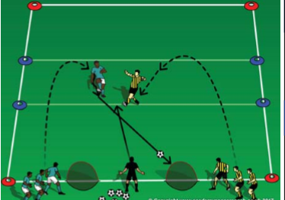

Set up two 15W x 20L fields with a goal at each end. When practice is scheduled to start and as soon as 2 players arrive, start playing a game. The game will start as 1v1. When the next player arrives, the game is 2v1 then 2v2 up to 3v3. After 1 field is at 3v3, start the second game on the field next to it

Observation: do the players struggle to stop the ball at the end line or before crossing a side line? Technical Tip: stop the ball on the end line with the bottom of the foot & use the inside or outside of the foot to steer the ball away from the sidelines.

**Key Coaching Points**

**Organization**

**3v3 Game**

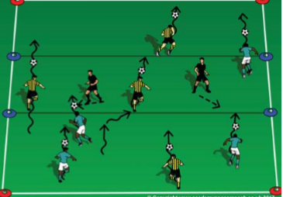

Is the activity organized? (cones, scrimmage vests, balls, players, goals) Is it reality-based? (does it look like a soccer game?) Is there repetition? (Focus on dribbling & striking the ball (session themes) Is it challenging? (Players should be engaged not frustrated or bored) Is there coaching? (Positive reinforcement of dribbling)

**Key Coaching Points**

**Organization**

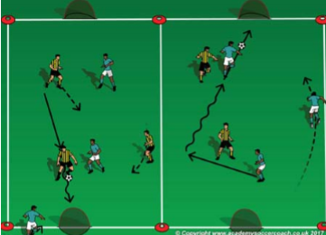

Tactical/Technical:

**Key Coaching Points**

**Organization**

**Game**

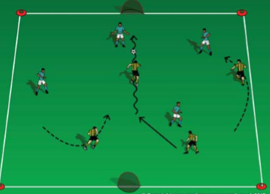

Observation: can the player with the ball reach the goal with a shot? Technical Tip: with the laces, push the ball closer to the goal before shooting. (points are not as important as the player's ability to score)

In a 15W x 20L grid & a 5 yard zone in the middle (the dog pound), coaches can start as dog catchers in the pound (dog catches do not use soccer balls and must stay in the pound). Each player has a soccer ball and start on one end line. On the coach's command, all players try to sneak through the pound without waking the dog catchers. If you wake a dog catcher and they steal your ball, you become a catcher.

In a 15W x 20L grid, a 5 yard middle zone & 2 goals on one end line: coach divides the group into 2 teams; 1 team-bulldogs & 1 team-dog catchers. Coach stands between the goals with all the soccer balls, plays a ball out and the first player from each team goes after the ball. Whoever gets the ball tries to score in the other team's goal. Any goal scored from the middle zone is worth 100 pts. all others 1 pt.

**Key Coaching Points**

**Organization**

Observation: do the players try to dribble around opponents or continue in straight lines? Technical Tip: use the inside or the outside of the foot to dribble side to side and the laces to go forward.

In a 20W x 30L field and a small goal on each end line, play a 4v4 game. If the roster & attendance is larger than 8, divide the group into 2 equal team, set up a second field and play 2 games at the same time. Take plenty of breaks for rest and water.