Coach: Date: Training Length:

Topic: Technical/Tactical:

Organization

**Activity 1**

**Activity 2**

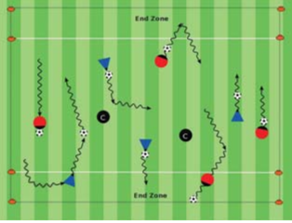

Objectives: Get the players to play the game. To dribble forward to get past opponents and score goals.

Organization: Set up 2-3 fields 15W x 20L w/a goal at each end. As players arrive to the field start to play 1v1, 2v1, up to 2v2 games.

Time: 4 games of 2 mins, 30 sec rest, activity duration is 10 min.

Rules: Start game w/a kick off. Out of bounds pass or dribble ball in. Allow periods of free play

Key Words: Look up, go around (the defender), get into space (an opening), go to goal.

Guided Questions: How can you get around or past a defender?

How can a dribbler find space (an opening to the goal)?

Answers: Change direction and go faster (accelerate) to get around defenders and into space (an opening). Use little touches to keep the

ball close and big touches after getting around defenders to go fast to goal. Describe "look up" as how to see where defenders are, where the opening to the goal is, where the goal is.

**Key Coaching Points**

**Warm Up**

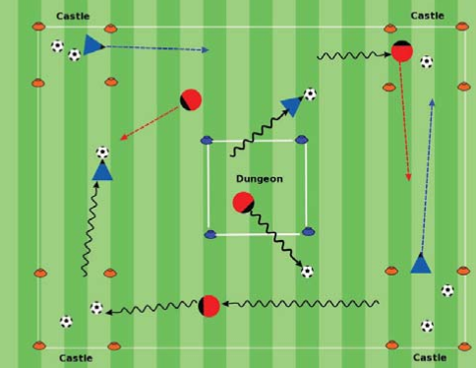

Key Words:

Find the opening, go to the goal,

go score

Guided Questions: Are all the players engaged in playing the game? How can you tell players

know the rules?

Answers:

Have multiple fields for all players to

play the game. Players are trying to keep the ball

in play, trying to score goals

**Key Coaching Points**

**Organization**

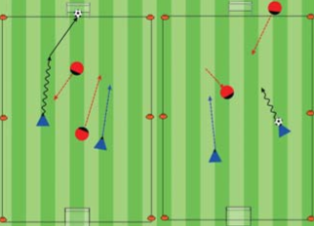

Tactical/Technical:

**Key Coaching Points**

**Organization**

**Game**

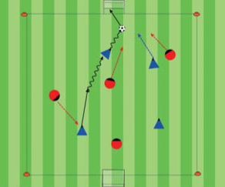

Key Words: Look up, go around (the defender), get into space (an opening), go to goal.

Guided Questions: How can you get around or past a defender?

How can a dribbler find space (an opening to the goal)?

Answers: Change direction and go faster (accelerate) to get around defenders and into space (an opening). Use little touches to keep the

ball close and big touches after getting around defenders to go fast to goal. Describe "look up" as how to see where defenders are, where the opening to the goal is, where the goal is.

Organization:20Wx25L field w/5yd

end zone @ each end. Players dribble past

opponents to each end zone & back. If

defender steals the ball, switch roles.

Rules: Every player w/ a ball in an end

zone. Coaches can be defenders. Coach

says "Go" to start. How many end zones

did you get to in 1 min, beat your score

**Key Coaching Points**

**Organization**

**Organization**

Objective: Players dribble past opponents and score by putting their ball their corner box (castle).

Organization: In 20W x 25L field, w/a 5yd box (castle) in each corner & one box in the center of the field (dungeon). Make 4 equal

teams, assign each team to a corner castle, name the castle.

Rules: Players start w/a ball in the dungeon. On Coach's "Go!", players will dribble to their castle & score by leaving their ball in the castle box. Players can then go and get balls out of other castles and dribble back to their castle, repeat. After 1 min which castle has the most balls in it.

Key Words: Look up, find an opening, move/go

around & between defenders (through the opening) to the goal to score

Guided Questions: When should players dribble?

How do you measure if practice was a success?

Answers: Dribble when there's space (an opening) infront, on the side, between or behind opponents to the goal. Players had fun. They tried to dribble forward past opponents to score

Objective: Players with the ball try to dribble by opponents and score goals.

Organization: On a 25W x 35L field w/ a small goal at each end. Play 4v4.

Time: Play a game for 30 min, 2 halves of 12

min with 3 min of rest after each half.

Rules: All modified 4v4 rules apply.