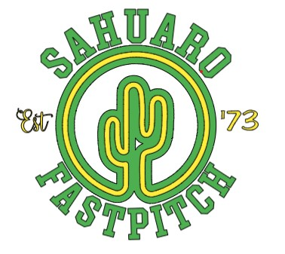

Snack Bar Agreement

Player Name: ___________________________________

The Snack bar is essential to Sahuaro Fastpitch Softball and its success depends on all parent volunteers. We look forward to working with all of you to make this season a great experience for our players, visitors, and fellow parents.
Please read the following guidelines for the SFP Snack Bar coverage:
Each team shall be assigned an even number of shifts to cover the snack bar throughout the entire season. All shifts will be assigned by the SFP board members, in correlation with the home game schedule. It is the responsibility of each Coach and/or team volunteer to coordinate coverage of the snack bar during their shifts.
Please arrive on time to your assigned shift to allow an easy and smooth transition from one team to another. Children under 16 may not operate the cash register, tablet, or hot food items.
By signing below, you acknowledge you have read and understand the SFP Snack Bar duties.

Parent/Guardian Name: ___________________________________________
Signature: _________________________________ Date: ________________
Sahuaro Fastpitch Softball
Email: President@sahuarofastpitch.com

