Player’s Name: ________________________________________________________
Division Registered and Team: _______________________________________
Uniform shirt size - Youth or adult: ________________________________
Form | Have/Need | Verification Method | Verified by Initials
Registration Form
Proof of age |  | Birth Certificate
Proof of residency |  | Groups 1, 2 and 3
Proof of residency |  | School Enrollment form  School name:
Medical release
Covid 19 & Model release
Volunteer Application |  | Dl and SSN entered
Westrock Application |  | Volunteer form
Residency shall be established and supported by documents containing the full residence which includes parent(s) or court-appointed guardian(s) name, street address, city, state, and zip code information dated or in force between February 1st of the previous year and February 1st of the current year, from one or more documents from each of the three groups outlined below:
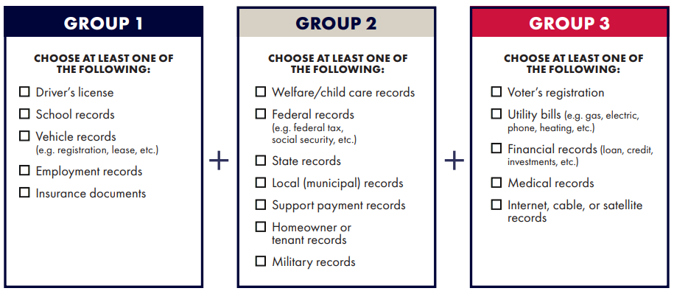
Note 1: Three documents from the same group constitute only one document.
Note 2: certain documents may be used in different groups but will count for only one group per child. Example – if a water/sewer bill is used to satisfy group ii as a municipal record, that same bill cannot be used as a utility bill to satisfy group iii.
Note 3: a school-issued report card/performance record will no longer be accepted to establish school attendance.

