**Be Inspired!**

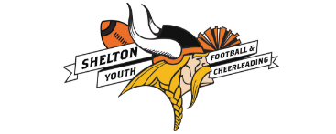







**The Shelton Vikings and the Wallingford Vikings are looking to enroll special needs children and young adults to join their Inspiration Cheerleading programs!!**

American Youth Football and American Youth Cheerleading provides an inclusive Cheerleading program developed to foster confidence and a sense of self-worth that extends beyond the gridiron and into the school, family and community.

Inspiration Cheerleading Teams provide youth with cognitive and physical disabilities the opportunity to transform their disabilities into abilities and achievements. Players learn about the health benefits and the value of regular exercise in order to become stronger and healthier. Children build a network of friends, support, and trust.

Both towns are expanding their Inspiration cheer programs to any special needs individual, male or female age 5 - 23, in their area that is interested in an interactive Cheerleading experience. Inspiration cheer provides a fun engaging environment focusing on activity and inclusion. Inspiration Cheerleaders will be guided by Viking Cheerleader Buddies to assist them during games and events throughout the 2018 season. Inspiration team members are invited to join on our August practice schedule if they so choose. The Inspiration team may cheer for specific home football games during regular and post season play.

Additionally, the Inspiration team will learn a short routine that they will perform at local, state, regional and possibly national competitions and other community events. The practice schedule to learn this routine will be incorporated into the master competition practice schedule and will not exceed 2 times per week.

**To learn more about an Inspiration Cheerleading Team nearest to you, please contact:**

**In the Shelton area: Patti Prodan email: sheltonyouthcheer@gmail.com**

**In the Wallingford area: Alysa Worthy email: wallingfordvikingscheer@gmail.com**