Metro Mavericks Registration
This tutorials purpose is to guide you through the registration process.

Navigate to the Metro Academy Website
To begin the registration process, please go to the Metro Academy web site at:
http://kcmetromavs.org

Select the “Register” Link
Click on the “Register” link on the main menu bar as shown in the screenshot below.

Bluesombrero
You will be transferred to the Metro Academy registration page at Bluesombrero. Bluesombrero is a service sponsored by Dicks Sporting Goods for athletic clubs to manage online registrations. We hope this service will not only simplify the administrative tasks associated with registrations but make the registration process easier and more convenient for those who choose to participate with Metro Academy.
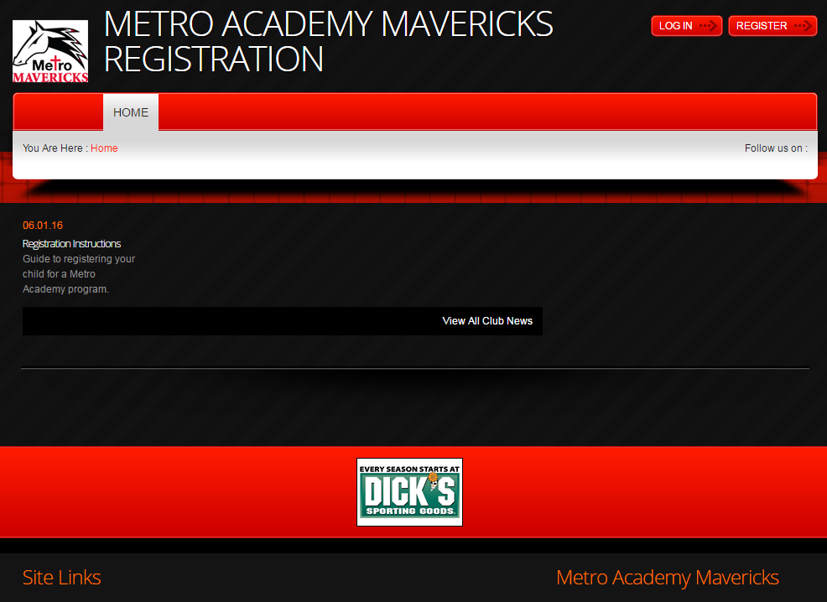

Select the “Register” Button
Click on the “Register” Button in the upper right corner of the page as shown below.

Create an Account
You will then be asked to create an account. Fill in the fields and press the “Create Account” Button at the bottom of the form.
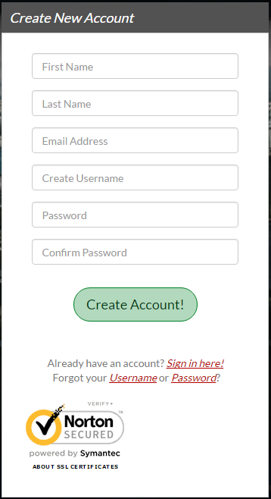
If you already have an account, below the “Create Account” button, select the “Sign in here!” link.
If you have an account and have forgotten your username or password select the links to retrieve your username or change your password.

Add Primary Parent/Guardian Information
You will now be asked to enter some personal information for you as the primary parent/guardian and a secondary parent/guardian if applicable. Please fill in all the required fields. Required fields are indicated by the * after the field description.
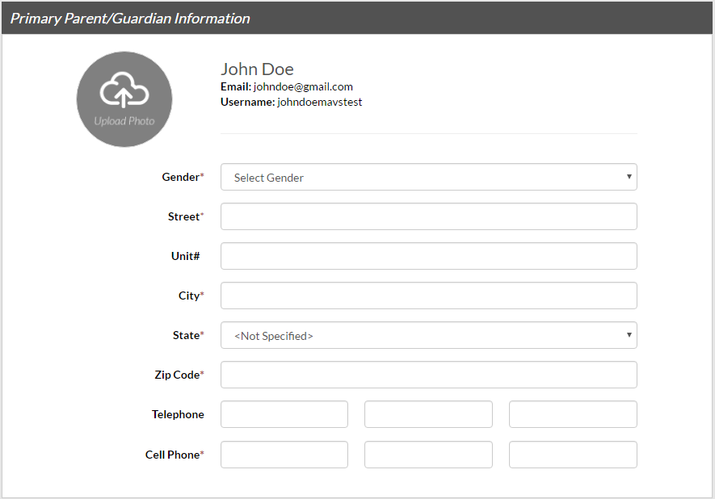
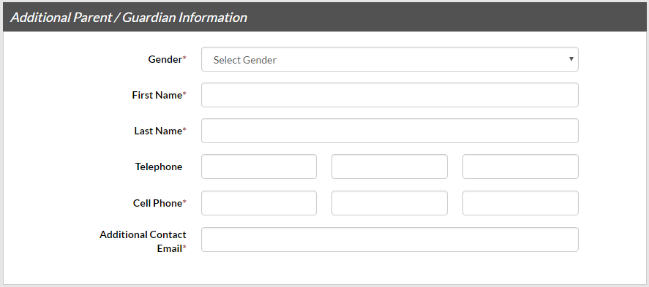
When all fields have been completed press on the “Create Additional Account User & Continue” button
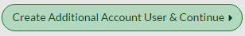

What Best Describes You?
You will then be asked in a pop up box, which best describes you. There are 2 choices, select the one that best describes you by clicking on the circular image above the description.
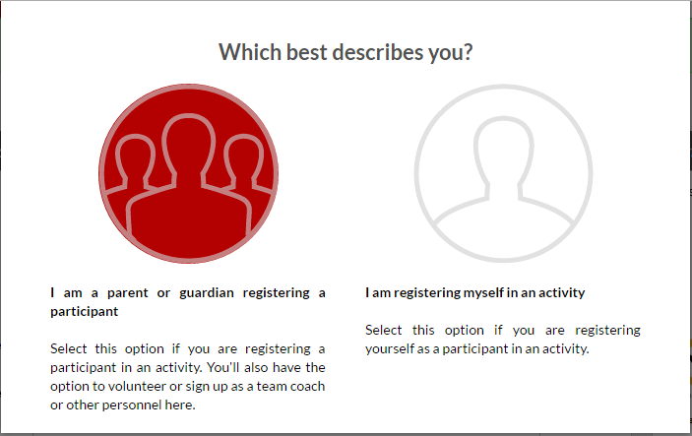

Add New Participant
Add a new participant by filling in the required fields in the form provided.
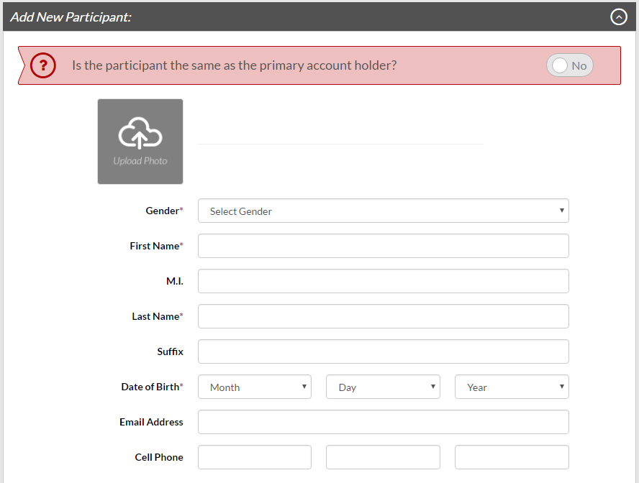
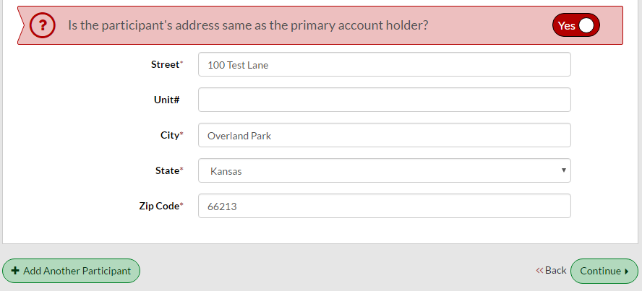
When the form is completed, choose to enter another participant by pressing the “Add Another Participant” button. Or, press the “Continue” button to move on in the registration process when done entering participants.

Available Programs
Based on the information entered for each participants, each program that each participant is eligible to register for should be presented.
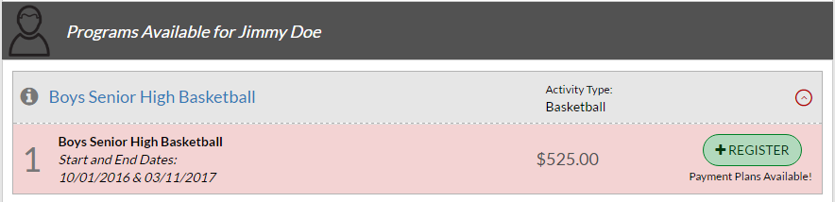
To register them in a program, press the “Register” button. The button will change to a “Selected” label.
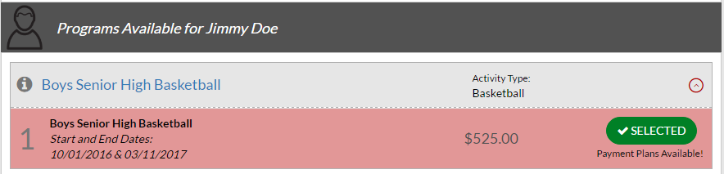
When you have selected all the programs you intend to register in for each participant, press the “Continue” button at the bottom of the page.

Program Information
Fill in the program specific information for the participant in the form presented.
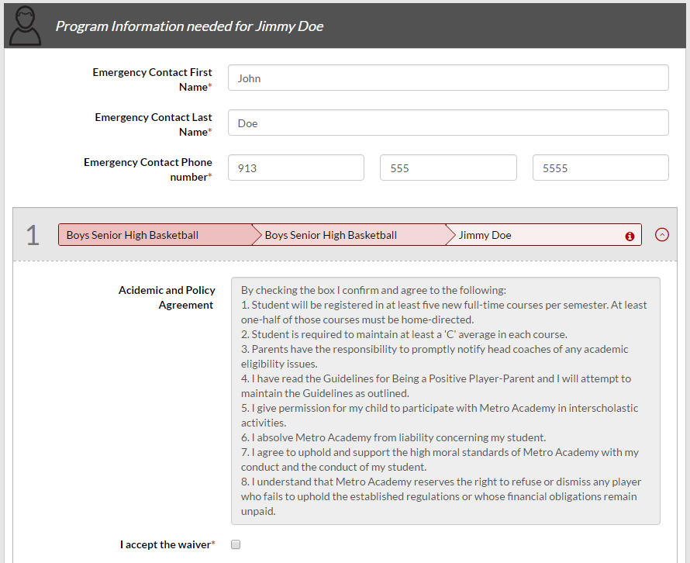
All required fields must be completed or the registration for the program will not be allowed to move forward.
When the form is completed press the “Continue” button at the bottom of the page.

Registration Summary
The program registration summary is presented. Fees and payment options are listed in the summary.
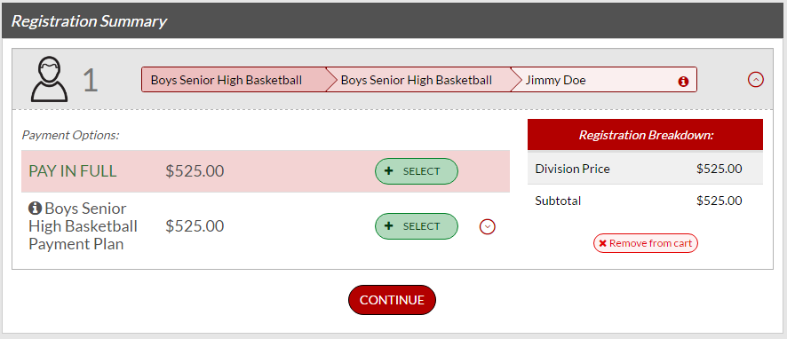
Select the option you prefer and then press the “Continue” button.

Review Payment Information
Payment information will be presented for review. At this time the only payment option available for registration into Metro Academy programs is by check. Instructions on where to send payment will be given later in the registration process. If the information presented is correct press the “Continue” button.
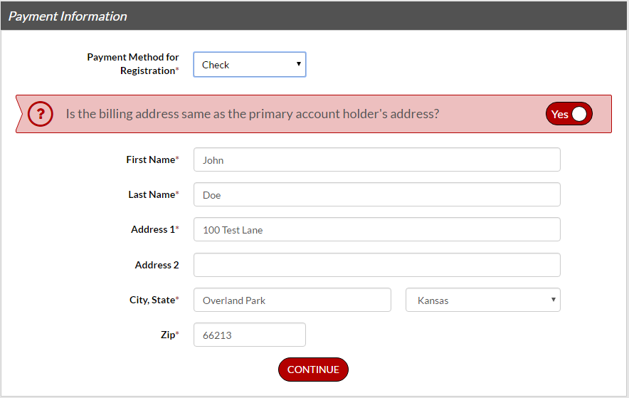

Registration Confirmation
A confirmation will be presented. Once reviewed press the “Continue” button.
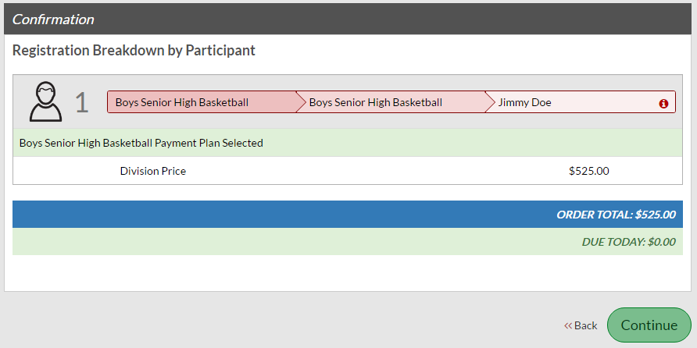

Registration Order Summary
Congratulations! You have reached the end of the registration process. But wait there is more. Because we are a KSHSAA approved organization there are some further steps to complete. Health Physical, Educational Eligibility and Concussion Awareness/Waiver forms need to be completed. Finally, our practice facility has a required waiver form that must be completed.
Instructions and links to the forms are given in the registration summary presented as well as the address to mail these completed forms and fee payments.
You will also receive a confirmation email with this same information, Please read the confirmation email in its entirety. Not completing these final manual steps could result in your child being held from participating in practices and games.
Thank you for choosing to participate with Metro Academy. Welcome to the Mavs Family!
