Coach: Date: Training Length:

Topic: Technical/Tactical:

Organization

**Activity 1**

**Activity 2**

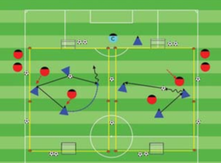

Objective: To score goals. To get players into a game as

soon as they arrive to practice.

Organization: Set up two or more 20Wx30L fields with a goal at each end. As the players arrive, play 1v1, 2v1,

2v3, up to 4v4.

Time: 3 games of 2.5 minutes, 30 second rest:

for a total of 9 minutes

Rules: Out of bounds - Pass or dribble the ball in

Key Words: Penetrate, Move the ball to move the opponent, quickly get Behind, Forward and to the Sides of the ball, Be available to receive a pass.

Guided Questions

When and why we need to pass backwards?

- Why do we change the point of attack?

Answer:

Too many defenders in front, and we want to keep

possession of the ball.

To get the ball to the opposite side and get the ball forward through

the opening in the flank.

**Key Coaching Points**

**Organization**

**Warm Up**

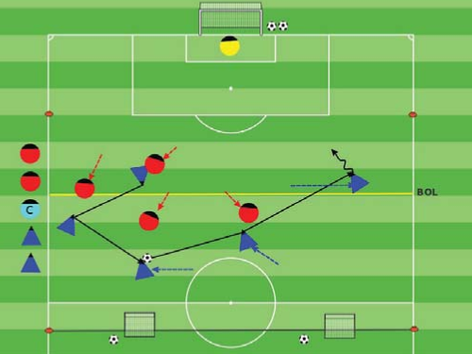

Key Words: Go to goal, Provide assistance

(Behind, sides and in front of the ball), Be

available to receive a pass.

Guided Questions:

- How fast did the players get to play?

- How are the players working together to get

the ball forward?

Answer: As they arrive they started to play.

The players are passing forward, backwards and

sideways to find an opening to go forward.

**Key Coaching Points**

**Organization**

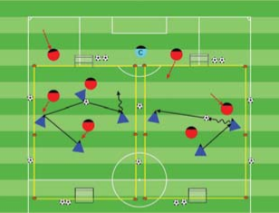

Tactical/Technical:

**Key Coaching Points**

**Organization**

**Game**

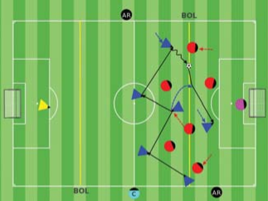

Key Words: Penetrate, Move the ball to move the opponent, quickly get Behind, Forward and to the Sides of the ball, Be available to receive a pass.

Guided Questions

When and why we need to pass backwards?

- Why do we change the point of attack?

Answer:

Too many defenders in front, and we want to keep

possession of the ball.

To get the ball to the opposite side and get the ball forward through

the opening in the flank.

Objective: To unbalance and disorganize the opponent creating or finding an opening to pass or dribble forward and create scoring chances.

Organization: - Play 5v5 in a 40Wx35L field with a regular goal and two counter goals.

Scoring: Blue scores in the regular goal, Red in the counter goals. Sub Blue and Red players every interval.

Rules: All FIFA Laws apply. After a goal Blue passes the ball in from the end line, Red gets a goal kick. Build out line is in effect.

Organization: Play 3v2's

- Two 20Wx30L fields with small goals

- Sub the Blue and Red players every

interval.

Rules: Out of bounds

- Pass or

dribble the ball in.

**Key Coaching Points**

**Organization**

Key Words: Penetrate, Move the ball to move

the opponent, Quickly get Behind, Forward and

to the Sides of the ball, Be available to receive a

pass.

Guided Questions:

- How do we know that players understand when

to go forward with a pass?

Answers:

The players successfully recognized

when to pass forward through an opening to a

receiver in between the defender's lines.

Objective: To unbalance and disorganize the opponent by passing and dribbling in the opponent's half in order to create scoring chances.

Organization: In a 40Wx60L field with regular goals make two equal teams.

Time: 2 halves of 13 minutes, 2 minutes rest for

a total of 30 minutes.

Rules: All FIFA Rules Apply.