Coach: Date: Training Length:

Topic: Technical/Tactical:

Organization

**4 Surfaces Dribbling**

**Crocs In The River**

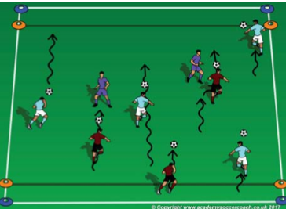

Set up two 15W x 20L fields with 3 tall cones on each end line. When practice is scheduled to start and as soon as 2 players arrive, start playing a game. After 1 field is at 3v3, start the second game on the field next to it. If you knock a cone down with the soccer ball, carry it back to your end line. First team with all 6 cones, wins the round. Reset cones, play again. (game is similar to capture the flag

Observation: are the players able to remember all the surfaces? Technical Tip: have the players call out the surface as they use it (outside-inside laces-bottom).

**Key Coaching Points**

**Organization**

**3v3 Games**

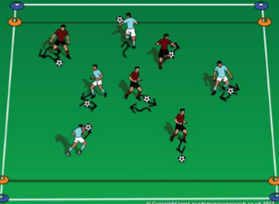

Is the activity organized? (cones, scrimmage vests, balls, players, goals) Is it reality-based? (does it look like a soccer game?) Is there repetition? (Focus on dribbling (session theme) Is it challenging? (Players should be engaged not frustrated or bored) Is there coaching? (Positive reinforcement of dribbling)

**Key Coaching Points**

**Organization**

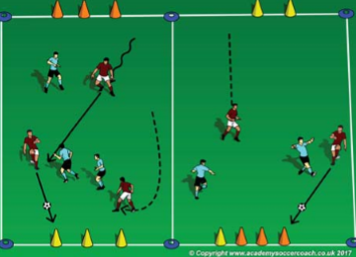

Tactical/Technical:

**Key Coaching Points**

**Organization**

**Game**

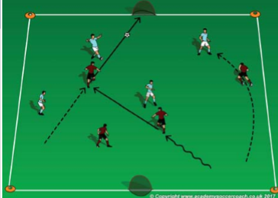

Observation: are the dribblers keeping the ball close when they are near a croc? Technical Tip: use soft touch when close to a croc by using the inside and outside of the foot; and big touches with the laces to push the ball past the crocs.

In a 15W x 20L grid, which includes a 3 yard end zone on each end line and each player with a soccer ball, have the players try to use 4 surfaces of their foot in 1 fluid motion & in order: Outside of the foot (pinky toe) - Inside of the foot (big toe) - laces & bottom (sole). Once the ball has been stopped, have them try it with the other foot. Players move throughout the field toward each end zone.

In a 15W x 20L grid, including a 3 yard end zone on each end line & each player starts with a soccer ball at one end (river's edge). The coaches start as crocs in the river. On the coach's command, the players have to dribble their soccer ball across the river and stop it on the opposite river's edge. If the dribbler can stop their ball in an end zone, they are safe but if a croc steals their ball, they become a croc also.

**Key Coaching Points**

**Organization**

Observation: Do the players keep dribble toward the goal? Technical Tip: Encourage the players to lift up their head while dribbling so they know the direction to the goal.

In a 20W x 30L field and a small goal on each end line, play a 4v4 game. If the roster & attendance is larger than 8, divide the group into 2 equal team, set up a second field and play 2 games at the same time. Take plenty of breaks for rest and water.