Coach: Date: Training Length:

Topic: Technical/Tactical:

Organization

**Activity 1**

**Activity 2**

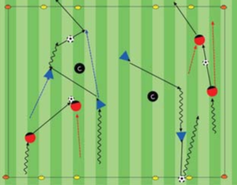

Objectives: Let the players play the game. To pass or dribble forward to get past opponents and score goals.

Organization: Set up 2-3 fields 15W x 20L w/a goal at each end. As players arrive to the field

start to play 2v1, 2v2, up to 3v3 games.

Time: 4 games of 2 mins, 30 sec rest, activity

duration is 10 min.

Rules: Begin game w/a kick off. Out of bounds,

pass or dribble ball in. Let players have free pl

Key Words: Get into or move to (open) space, find an opening (or create an opening) dribble or pass forward (through an opening) to a

teammate to score

Guided Questions: Where should the player w/out the ball go to help their teammate? When is the activity working?

Answers: Players w/out the ball can go away from defenders into open space, into an opening to the goal. Show players what "open space" or an "opening" between players looks like, where to find it, or how to make it. When players are making multiple passes that

reach their partners to score.

**Key Coaching Points**

**Organization**

**Warm Up**

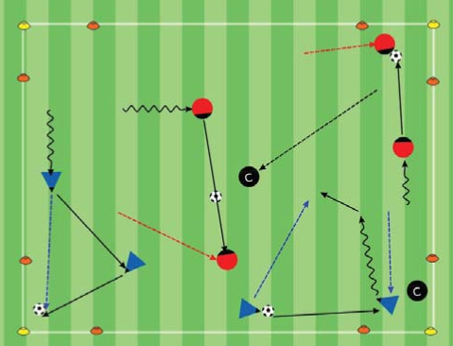

Key Words: Go score, move up the field, go

help, find an opening (path) to the goal

Guided Questions: How can you tell players

understand when to go forward (attack)?

How can you make the games easier or harder?

Answers:When players have the ball they are

trying to get the ball forward through an opening

to the goal to score. Play uneven numbered

games like 2v1, 3v1 or 3v2

**Key Coaching Points**

**Organization**

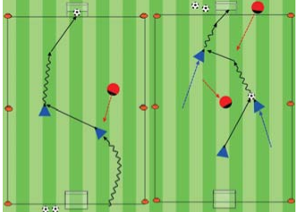

Tactical/Technical:

**Key Coaching Points**

**Organization**

**Game**

Key Words: Get into or move to (open) space, find an opening (or create an opening) dribble or pass forward (through an opening) to a

teammate to score

Guided Questions: Where should the player w/out the ball go to help their teammate? When is the activity working?

Answers: Players w/out the ball can go away from defenders into open space, into an opening to the goal. Show players what "open space" or an "opening" between players looks like, where to find it, or how to make it. When players are making multiple passes that

reach their partners to score.

Objective: Players pass, dribble & move into and out of space, past defenders to score.

Organization: 20Wx25L yd grid, w/4 corner cone goals. Each pair has a ball. Have 2 defenders. Coaches can be defenders. Defenders can move throughout the field & from goal to goal to defend the goals.

Rules: On coach's command pairs will pass & move w/partner. Score by passing to your partner in a corner goal, through a goal, or as your partner

arrives into the goal. Repeat at a different goal. If a defender steals the ball, steal it back. 1 million pts for each goal you pass into or through w/your partner in 1 min. Bonus points for a successful pass into or through a goal

that has a defender in it.

Organization:20Wx25Lyd grid w/2

goals on each endline. Pairs pass, dribble,

move to get past defenders & score goals.

Rules: Players in pairs w/a ball. Coaches

can be defenders. Pass & move w/the ball.

Score in one goal then pass w/partner &

score in a goal on other side, repeat. How

many goals in 1 min, beat your scor

**Key Coaching Points**

**Organization**

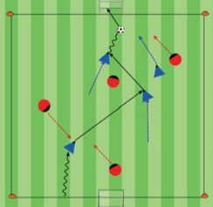

Key Words: Find an opening, get through, go score

Guided Questions: When should players pass? How can you recognize players are engaged in the game?

Answers: Pass to a teammate when a teammate is in an opening to the goal, has more open space to the goal, or that teammate can shoot right away. Players are paying attention, and trying to score goals to win the game

Objective: Team with the ball tries to pass &

dribble forward past opponents to score goals.

Organization: On a 25W x 35L field w/ a small

goal at each end. Play 4v4.

Time: Game is for 30 min, 2 halves of 10 min

with 5 min of rest after each half.

Rules: All modified 4v4 rules apply.